**MINI PROJECT REPORT**

**ON**

# SMART BLIND STICK

**MALAVIYA NATIONAL INSTITUTE OF TECHNOLOGY, JAIPUR**



**Session 2022-23 B.Tech. 2nd Year (3rd Sem.)**

**SUBMITTED TO- SUBMITTED BY-**

# Dr. Saravana Prakash P Vaishnavi Agrawal

|  |  |
| --- | --- |
| **Assistant Professor Electrical Engineering** | **(2021UEE1309)** |
| **MNIT Jaipur** | **Zeel Pokar** |
|  | **(2021UEE1336)**  **Jamna Bishnoi** |
|  | **(2021UEE1214)** |
|  |  |
|  |  |

# EQUIPMENTS

|  |  |  |
| --- | --- | --- |
| **S. No.** | **NAME** | **Cost** |
| 1. | Arduino Nano | 270 |
| 2. | Ultrasonic Sensor (HC-SR04) | 110 |
| 3. | Buzzer | 10 |
| 4. | Vibrating Motor | 5 |
| 5. | Battery (9V) | 30 |
| 6. | On-Off Switch | 5 |
| 7. | Jumpers(Male-Male, Female-Male,Female-Female) | 23 |

(Per Person Cost-150)

**INTRODUCTION**

The project describes ultrasonic blind walking stick with the use of Arduino nano. According to World Health Organization (WHO), 30 million people are permanently blind and 2.85 million people with vision impairment. If you notice them, you can very well know about it they can’t walk without the help of other. One has to ask guidance to reach their destination. They have to face more struggles in their daily life. Using this blind stick, a person can walk more confidently. This stick detects the object in front of the person and give response to the user either by vibrating or through command. So, the person can walk without any fear. This device will be best solution to overcome their difficulties. We have made this project using ultrasonic sensor and Arduino nano.

**WORKING**

* The **Smart Blind Stick** scans the path in front of it with the help of an ultrasonic sensor.
* Whenever the sensor detects any object in its path the buzzer starts beeping.
* The blind person can hear the beeping of the buzzer and manage to change the way. In this way, the person can easily find his way without getting injured.
* This smart stick works in the same way as the Ultrasonic Range Finder does. You can also see the real-time values of the distance in cm on the Arduino serial monitor.

**CIRCUIT DIAGRAM**

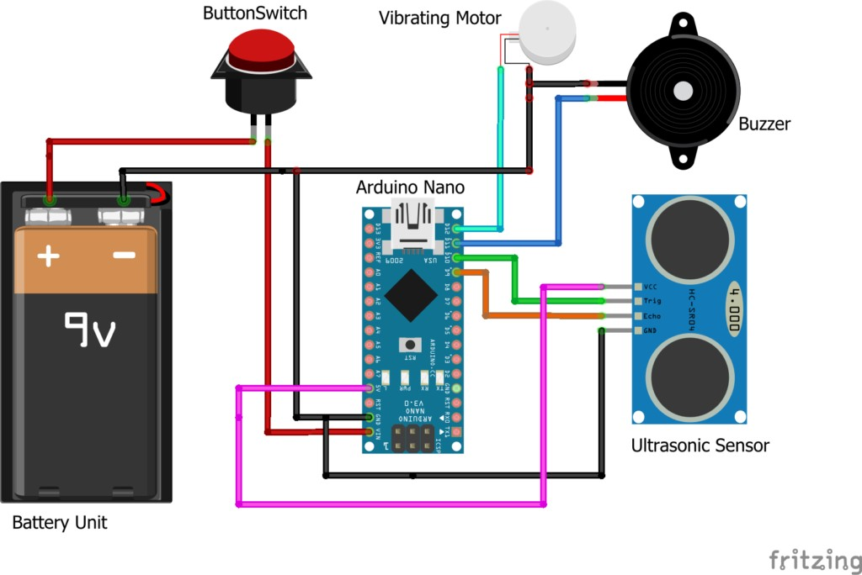

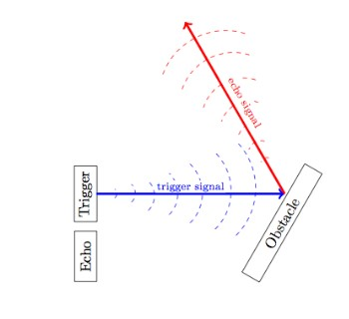

Working of Ultrasonic Sensor

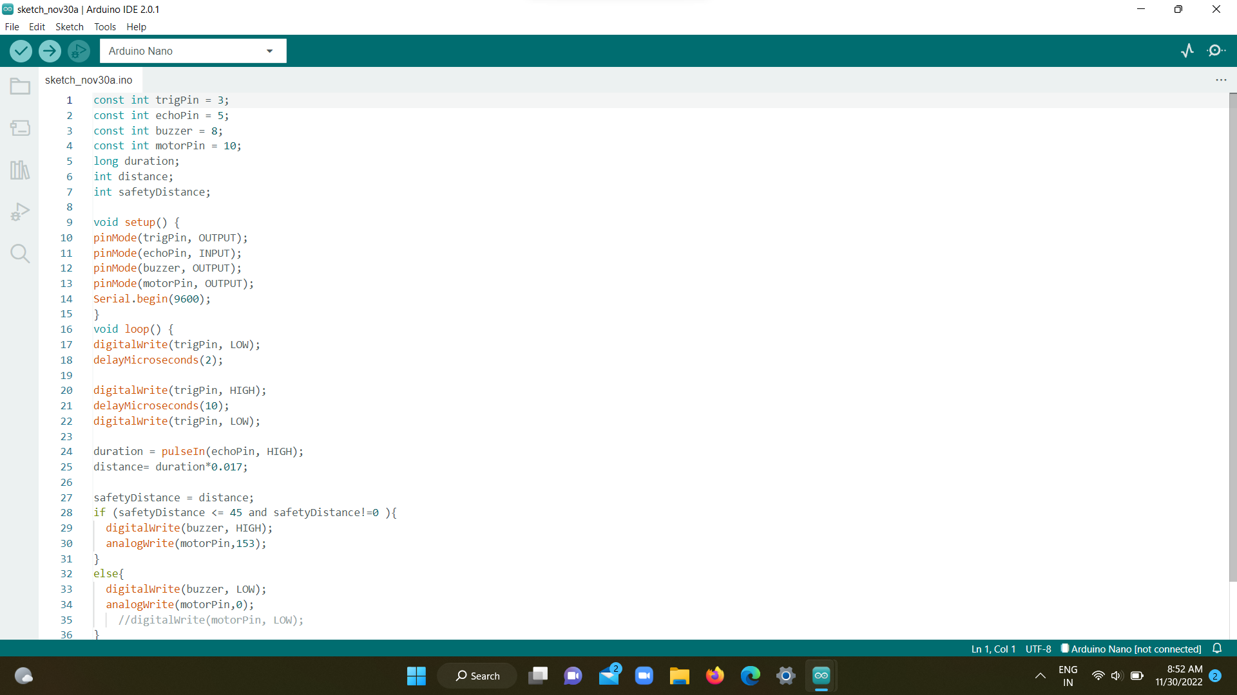

**ARDUINO CODE**



**PROJECT PHOTO**

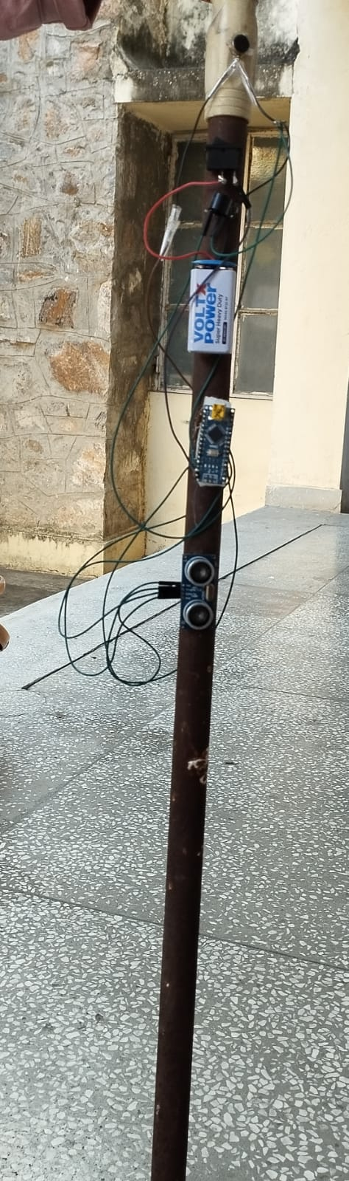

**REFRENCES**

[**https://create.arduino.cc/projecthub/mohammadsohail0008/smart-stick-for-blind-peoples-5ee884**](https://create.arduino.cc/projecthub/mohammadsohail0008/smart-stick-for-blind-peoples-5ee884)

[**https://techatronic.com/smart-blind-stick-using-arduino-and-ultrasonic-sensor/**](https://techatronic.com/smart-blind-stick-using-arduino-and-ultrasonic-sensor/)

[**https://youtu.be/HEMtTqdMRRQ**](https://youtu.be/HEMtTqdMRRQ)

[**https://www.researchgate.net/publication/273452928_Effective_Fast_Response_Smart_Stick_for_Blind_People**](https://www.researchgate.net/publication/273452928_Effective_Fast_Response_Smart_Stick_for_Blind_People)